Looking into the Future: Bionic Eyes
Human biology is a finicky thing to maintain. However, emerging biotechnologies will hopefully help improve quality of life. The field of bionics looks promising, keeping technology and humanity closely intertwined. An exciting recent development in biotech surrounds bionic vision. 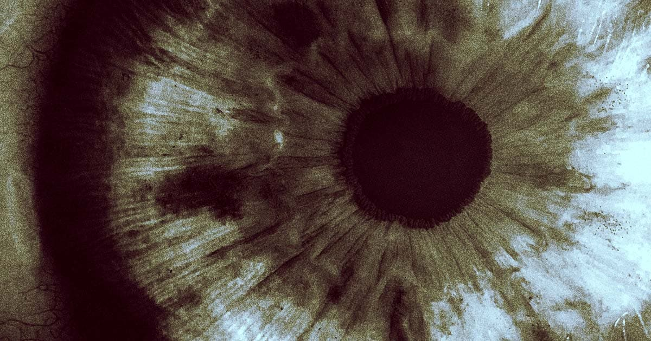
New Brain Implant Lets Blind Patient See Without Eyes (futurism.com)
Spanish researchers from Miguel Hernández University developed a brain implant to enhance vision in the visually impaired (1). At a length of 1.5 mm and a width of 4 mm, the current device consists of a “three-dimensional matrix of 96 micro-electrodes” (1). The implant is also connected to a camera, allowing it to process light signals and send them as feedback to the electrodes. Finally, these electrodes interact with neurons within the brain tissue. The device was first tested on primates, to strong success. The researchers then conducted studies with the help of a 57-year-old woman, who had been blind for 16 years (1). The implant was carefully placed along the visual cortex of her brain.
Despite the system containing several components, the researchers reported a low power draw on their device when compared to similar systems (2). Furthermore, studies showed that the only neurons affected by the electrodes were the target neurons, with neurons outside of the visual cortex being unresponsive to the electrical signals (2). However, the most reassuring data from the research was that the visual apparatus allowed the woman to identify letters, and various other “shape boundaries” (2) . More volunteers for the technology are currently being recruited, and outlook on its development is promising.
Seeing where technology is going can be a difficult task. Bionic vision technology may very well be a next step in biomedical technology. That said, depending on how the research develops, it just as easily may be a dead end. In either case, the research is bound to provide us knowledge that is of value. New technologies and innovations allow us to make the lives of others better. Thus, when this goal is at the forefront of scientific efforts, it is always a good sign.
Sources:
- Brain implant bypasses the eyes to help blind users "see" images (newatlas.com)
- New Brain Implant Lets Blind Patient See Without Eyes (futurism.com)

